

Software Project

**Aaron McCormack**

**N00212142**

Software Project

Sign Language Website

Year 2 2022-23

DL836 BSc (Hons) in Creative Computing

Link to resources created as part of the project.

|  |  |
| --- | --- |
| GitHub | <https://github.com/y2-SW-project/swproject23-RiddleASL> |
| Video | Link to your video file (MS Stream, YouTube) |

Table of Contents

1 Introduction 1

2 Business Concept 2

2.1 Business Idea 2

2.2 Business model 2

2.3 Market Research 2

2.4 Marketing/Advertising 2

2.5 Suppliers 2

2.6 Competitors 2

2.7 Employees 2

2.8 Environmental Impact 2

3 Requirements 3

3.1 Introduction 3

3.2 Requirements gathering 3

3.2.1 Similar applications 3

3.2.2 Interviews 3

3.3 Requirements modelling 3

3.3.1 Functional requirements 3

3.3.2 Non-functional requirements 3

3.3.3 Use Case Diagrams 4

3.4 Feasibility 4

4 Web application Design 6

4.1 Layout 6

4.2 Interaction 6

4.3 Colour schemes 6

4.4 Font choices 6

4.5 Wireframes 6

5 Database Design 7

5.1 Description 7

5.2 Business Reporting Requirements 7

5.3 Textual Representation of Data-Set 7

5.4 Business Rules 8

5.5 Entity Relationship Diagram 8

5.6 Tables 9

5.7 Database Dictionary 10

6 System Design/ Architecture Overview 11

6.1 Introduction 11

6.2 Model View Controller 11

6.3 User Authenticaion 11

6.4 Routing 11

6.5 Templating 11

7 Testing 12

7.1 Introduction 12

7.2 Functional Testing 12

7.2.1 Login/Registration 13

7.2.2 Navigation 13

7.2.3 Calculation 13

7.2.4 CRUD 13

7.2.5 Discussion of Functional Testing Results 14

7.3 User Testing 14

7.4 Conclusion 14

8 Project Management 15

8.1 Introduction 15

8.2 Project Phases 15

8.2.1 Requirements 15

8.2.2 Design 15

8.2.3 Implementation 15

8.2.4 Testing 15

8.3 SCRUM Methodology 15

8.4 Project Management Tools 16

8.4.1 Github Project 16

8.4.2 GitHub 16

9 Reflection 17

9.1 Your views on the project 17

9.2 How could the project could be developed further? 17

9.3 Assessment of your learning. 17

9.4 Completing a large software development project 17

9.5 Technical skills 17

9.6 Further competencies and skills 17

10 References 18

# Introduction

Application area

Technologies

PHP, MySQL, Bootstrap, CSS, Vanilla

Tools

IDE, phpMyAdmin, Miro

Project management

GitHub

Business Concept

Requirements

Design

Implementation

Testing

Reflection

# Business Concept

## Business Idea

For my Software Project I had made the decision to create a website based around the idea of a community run Sign Language website. Using this, people will have the ability to select the Sign Language of their choosing, look up words and get videos of Deaf/Hoh/Fluent members performing the sign, research into the languages culture and history, interact with other users via forums, find extra external sources of information as well as join communities on social media (Facebook, Discord, Reddit, Etc.).

## Business model

For this website, I plan on gaining revenue based off donations from the general public as well as advertising. With advertising we will outsource to D/HOH people who wish to advertise their stores on the website and generating revenue based off how many clicks the website gets. This would be optimal as it would allow Sign Language based products made and produced by D/HOH people to be advertised.

## Market Research

There are plenty of people, from general public to students, who are constantly looking for new resources to increase their understanding of sign language, vocab and culture from reliable sources. This would be ideal as it would be sourced from D/HOH instead of spread by someone who is hearing.

## Marketing/Advertising

I could advertise my site via social media such as Instagram, Reddit, Discord etc. This would allow people who use these kind of research tools to the daily. With the idea of allowing people to advertise their own stores it would be a big sense of community as they sell

## Suppliers

With the website, I have plenty of resources I could use to supply my website. These could range from volunteers to D/HOH employees who are willing to record and contribute to the word bank for a Sign Language. When it comes to marketing, there are a lot of already existing D/HOH run stores that I could reach out to and ask if they wish to support by advertising their site.

## Competitors

Competitors, while I prefer to call them external resources, there are other places that people can use to teach themselves the culture and language but I would like to work along side these people rather than against. Potentially adding their pre-existing words/videos alongside this website.

## Employees

When it comes to front-end/back-end/software wise, anyone could work within the website. If it concerns the community within the forums, if it concerns questions about culture or history it would be answered by a D/HOH person, if concerning a word that they wish to know it would be answered by anyone with the necessary qualifications and knowledge.

## Environmental Impact

# Requirements

## Introduction

The purpose of the requirements phase is to allow for developers to work out what the application should be able to do. It is important to understand what the users would like the application to do rather than the developer deciding what is required.

You can write a bit about your project area. Each paragraph has a blank line between it and the previous paragraph

Here I would like to describe the requirements that I see fit for this website. Going over what the admins should have control over, can view and edit as well as what the public users are allowed to view and what actions they can perform. Being focused on a language that is a primary form of communication for a population of people, the main importance is that we are accurate, up to date and all the statements are true. Later I will explain how we can achieve this.

## Requirements gathering

### Similar applications

Look at and document 2 similar applications. Be sure to include the following for each:

* Screen shots
* Descriptions
* Advantages
* Disadvantages

First we will look at the two main sites I and countless others have used for by students and the public to research and learn American Sign Language (ASL).

**Lifeprint** [**(https://www.lifeprint.com/)**](https://www.lifeprint.com/)



Lifeprint is an independent site run by deaf ASL lecturer Bill Vicars. Bill has been supplying free resources that the public can look at for years. Well known for his YouTube channel with 40-minute-long lessons going from the bare basics to advanced vocabulary, also owns this website that anyone can use to learn and follow along with the videos. While a lot of what I wish for my website to become is like his, I want to point out disadvantages and advantages I can see.

|  |  |
| --- | --- |
| Advantages | Disadvantages |
| * Free resource that anyone with a Wi-Fi connection can access and learn from. * Vast vocabulary and lessons on rules with lots of detail * Can ask personalized questions with quick response times via email. | * The site is old and dated. Even as a user for over a year, I struggle sometimes to navigates * The webpages are all very wordy with little indication to show where your eyes go |

**Handspeak** [**(https://www.handspeak.com)**](https://www.handspeak.com)

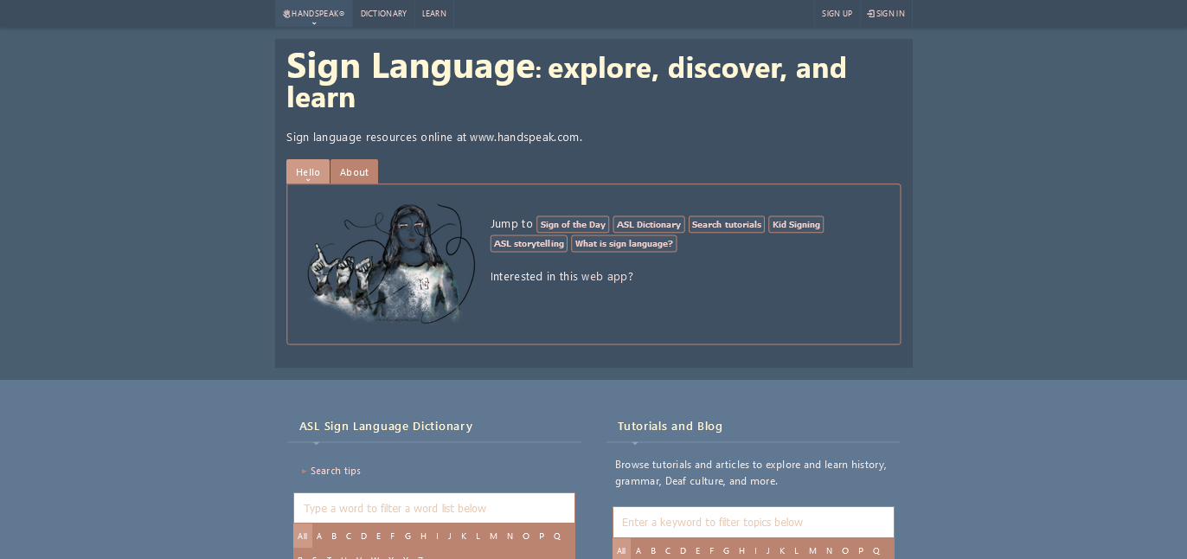

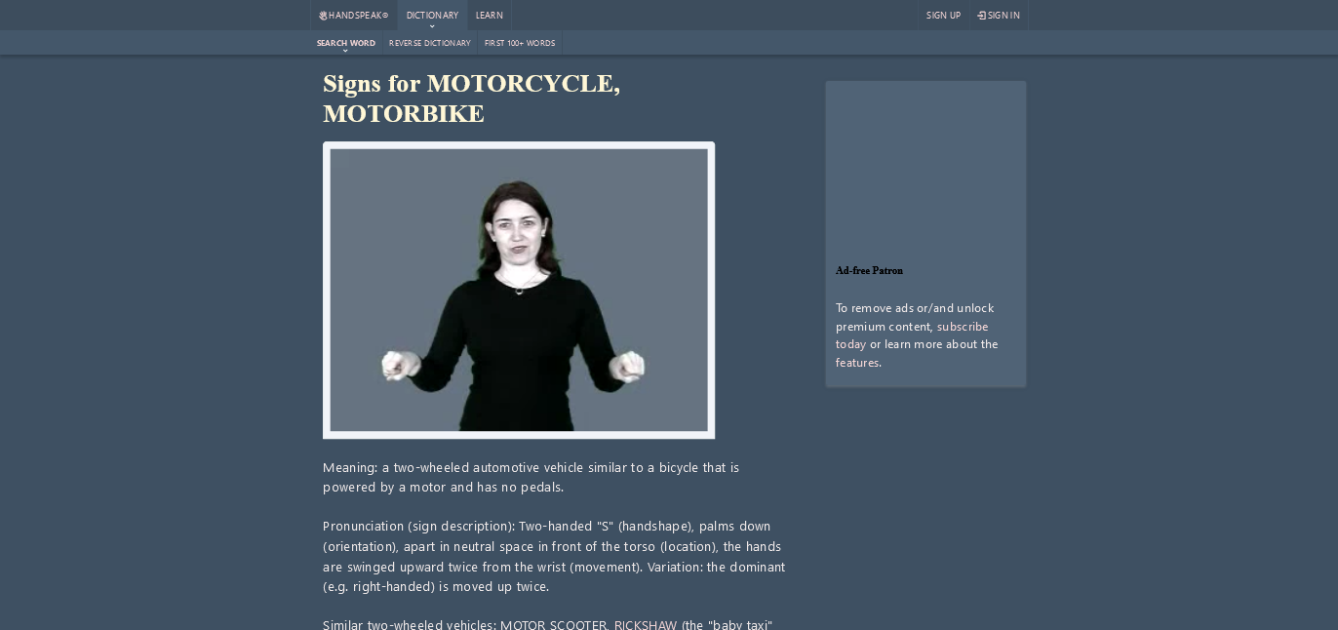

Handspeak is a Deaf run website by a born deaf woman, Jolanta Lapiak. The website runs similar to Lifeprint but as you can see is considerably more modern. Providing similar options to learn grammar, culture, history and the language itself. It is another free resource that is popular amongst the Deaf and Hearing community.

|  |  |
| --- | --- |
| Advantages | Disadvantages |
| * It is very simplistic making it easy to navigate. * The descriptions to the sign you click on are well put and allow you to navigate to signs that look similar or have similar meaning | * Some videos are outdated/corrupted so they no longer play * The color selected for the links is a pale beige/red which makes it very hard to differentiate between normal text and clickable text |

### Interviews

Conduct interviews with 2 or 3 users to find out what the important features for them for the app are. There may be various issues that arise in multiple interviews. These can be grouped together into a number of themes.

Interviews are currently being organized. Currently I only have a questionnaire that has very little responses as of typing. I wish to give it a week to get as many responses as possible.

## Requirements modelling

### Functional requirements

Create a numbered list of what the application should be able to do. Start with the most important feature.

In this website you should be able to search up a word and if that word exists in the collection of signs, be shown a video and definition of the word you selected. You should also be able to swap from one sign language to another with a click of a button within the same page to view the word in multiple languages if wanted.

You should be able to view the history and culture of the selected language that the user has chosen. The users should also be able to view additional resources that link to other websites, communities and social media that people can use to educate themselves on the language

If given enough time, the user should be able to submit videos and forums that allow for community run word bank and forum. This allows the community to be self-sufficient with admins to confirm and verify new words and that the forums are user friendly and regulated by rules set upon the sites launch that users must agree to before posting.

### Non-functional requirements

These are requirements which if not met do not stop the application from working, but which mean that the application is not working as well as it should. They are usually based on issues such as:

* Usability
* Performance
* Security

For usability purposes, I want the website to be as user friendly as possible to ensure that the user gets the results of their question as quickly as possible. This would mean looking at the site as a whole and questioning where we can and can't minimize actions to achieve the goal. Security is not the largest but it is still important as we want the information to be as accurate as possible.

### Use Case Diagrams

Consists of actors and use cases. You should document each individual use case.

Here you can see how users and admins will be permitted to perform other actions.

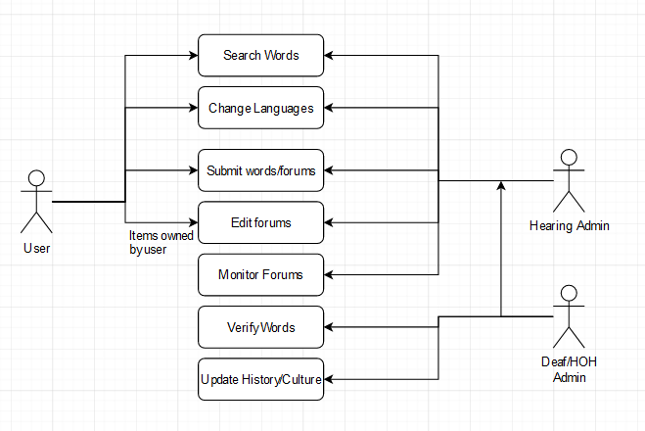

## Feasibility

This section describes which technologies are planned to be used in the development of the application. It then explains if there are any issues in terms of the technical feasibility of the project, for example, if there are two different types of software which may have compatibility issues.

During the development, I plan on using Laravel as the backend framework and Bootstrap as the frontend framework with the help of SCSS. As of writing I have not worked with both in tandum so I can not give an accurate report on the feasibility of the development. This will be updated as I do so but I expet very little to conflict with eachother.

# Web application Design

## Layout

Describe the layout of your web application. Does this depend on a framework like bootstrap? Is it responsive?

The layout for this application will be dependent on bootstrap for its responsivity. This is a very important part as I want the site to be readable upon mobile devices and montiors regardless of the screen size.

## Interaction

What are the navigation elements, form elements. How does the user interact with the application?

The interaction between the user and the application will be mainly within the search of the word bank. Allowing the user to search for words, the database gives a list of available words and once upon clicking, a video will appear showing the sign in that language. If the word is not available, it will give the user the option to submit a video and description for moderators to confirm.

Users may also be allowed to create a user account, submit forums and advertise products sold by them is the advisory teams allows It. This gives the site a bigger sense of community as well as allowing the window of potential monetary income from advertising slots.

## Colour schemes

Describe the colour palette that you will use consistently across the web application

## Font choices

Specify the fonts that you will use for different types of text. Include samples for paragraph text, headings and bold and italicised text.

## Wireframes

Describe how to navigate from one page to the next by adding a diagram of the different screens and what the main functionality is.

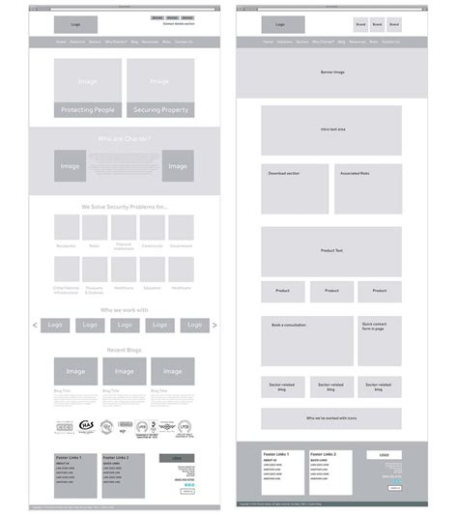

# Database Design

## Description

A company has a website that sells video games for different consoles. They would need a database for all their games and order places. For each order place, they would need games bought, total price, date of the order, and how long it will take to deliver. The database needs to keep track of all games that are being sold. Customers will have to input their information when registering an account. Customers will also have to input their card details when making a payment for their order.

## Business Reporting Requirements

Substitute in here the information the users of your application will want to be able to view.

1. Organisers need to be able to create, read, update, and delete: festivals, stages, shows, performers, and genres.
2. Users will need to be able to find all festivals ordered by their start date.
3. Users may want to find a festival by a specific start date.
4. Users need to find all festivals using a list of genres.
5. Users need to find the stage for a specific show.
6. Users need to find the shows using the performer's name.
7. Performers may need to find the list of festival contacts.
8. Users need to find festivals by location and the location needs to be displayed on a Google Map
9. Users may need to find festivals by city
10. Users need to find stages within a festival by the stage’s location
11. Organisers need to display a list of employees that are assigned to a specific festival

## Textual Representation of Dataset

Substitute in here the tables for your database

**FESTIVAL** (title, description, latitude, longitude, city, start_date, end_date, image_id)

**PERFORMER** (title, description, contact_email, contact_phone, image_id)

**GENRE** (title, description)

**IMAGE** (id, filename)

**SHOW** (date, start_time, end_time, performer_id, stage_id)

**STAGE** (title, description, location, festival_id, image_id)

**GENRE**_**PERFORMER** (id, genre_id, performer_id)

**EMPLOYEE** (name, phone, email)

**FESTIVAL_EMPLOYEE** (employee_id, festival_id, role)

## Business Rules

Substitute in here the business rules for your database

• A **Festival** has many **Stages**.

• A **Stage** belongs to one **Festival**.

• A **Stage** hosts many **Shows**.

• A **Show** is performed on one **Stage**.

• A **Performer** can perform in many **Shows**.

• A **Show** is performed by one **Performer**.

• A **Performer** can have many **Genres**.

• A **Genre** can belong to many **Performers**.

• A **Performer** can have a single **Image**.

• A **Festival** can have a single **Image**.

• A **Stage** can have a single **Image**.

• An **Image** can be associated with a **Performer**, **Festival**, or **Stage**

• A **Festival** can have many **Employees** associated with it

• An **Employee** can be assigned to one **Festival** at a time

## Entity Relationship Diagram

Substitute in here your ERD from draw.io

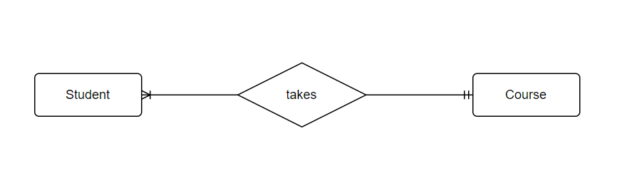

## Tables

Substitute in here your tables and the relationships between tables from draw.io in the format you used in DBMS with Mohammed.

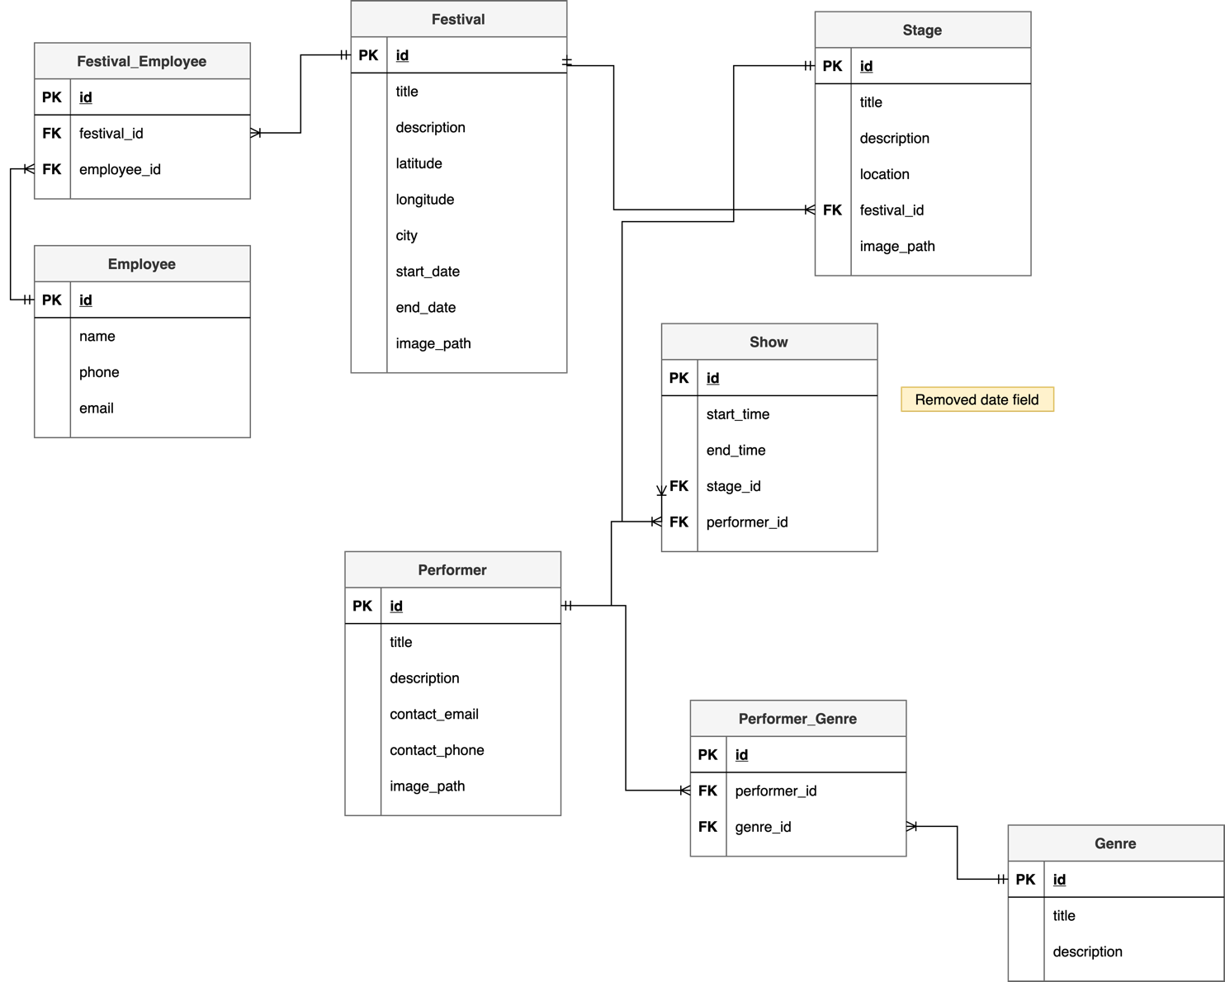

## Database Dictionary

|  |  |  |  |  |  |  |
| --- | --- | --- | --- | --- | --- | --- |
| Table | Attribute | Datatype | Range | Required | PK/FK | FK Ref Table |
|  |  |  |  |  |  |  |
|  |  |  |  |  |  |  |
|  |  |  |  |  |  |  |
|  |  |  |  |  |  |  |
|  |  |  |  |  |  |  |

# System Design/ Architecture Overview

* 1. Introduction

This section will describe the internal functionality of the web framework that you have chosen for the implementation. Add further sections if required by the specification of your web application

* 1. Model View Controller

Explain the follows a model-view-controller design pattern and how it is implemented in your web application.

* 1. User Authentication

Explain how user authentication is implemented in the web application framework.

* 1. Routing

Describe the routes that were defined in the web application

* 1. Templating

Describe the templating engine and how it was used to configure/ style the web application.

Add a sequence diagram in this section and other diagrams that illustrate the architecture clearly.

# Testing

* 1. Introduction

This chapter describes the testing that has been undertaken for the application. This chapter is presented in two sections:

1. Functional Testing
2. User Testing

Functional testing is a type of software testing whereby the system is tested against the functional requirements. The app is tested by looking to see if the actual output for a given input corresponds with the expected output. The tests should be based on the requirements for the app. The results of functional testing can indicate if a piece of software is functional and working, but not if the software is easy to use.

User testing looks to see if a piece of software is easy and intuitive for the user.

* 1. Functional Testing

This section describes the functional tests which were carried out on the app. These functional tests can be categorised as: (whatever is relevant to your app)

* Login/Registration
* Navigation
* Calculation
* CRUD

Functional testing generally uses a Black Box Testing technique which means that the internal logic of the system being tested is not of interest to the tester. The tester is only interested in whether the actual output agrees with the expected output.

* + 1. Login/Registration

|  |  |  |  |  |  |
| --- | --- | --- | --- | --- | --- |
| Test No | Description of test case | Input | Expected Output | Actual Output | Comment |
|  |  |  |  |  |  |
|  |  |  |  |  |  |
|  |  |  |  |  |  |

* + 1. Navigation

|  |  |  |  |  |  |
| --- | --- | --- | --- | --- | --- |
| Test No | Description of test case | Input | Expected Output | Actual Output | Comment |
|  |  |  |  |  |  |
|  |  |  |  |  |  |
|  |  |  |  |  |  |

* + 1. Calculation

|  |  |  |  |  |  |
| --- | --- | --- | --- | --- | --- |
| Test No | Description of test case | Input | Expected Output | Actual Output | Comment |
|  |  |  |  |  |  |
|  |  |  |  |  |  |
|  |  |  |  |  |  |

* + 1. CRUD

|  |  |  |  |  |  |
| --- | --- | --- | --- | --- | --- |
| Test No | Description of test case | Input | Expected Output | Actual Output | Comment |
|  |  |  |  |  |  |
|  |  |  |  |  |  |
|  |  |  |  |  |  |

### Discussion of Functional Testing Results

Describe the results from the tests. Address any functionality where unexpected behavior could not be debugged.

* 1. User Testing
  2. Conclusion

Discussion of test results.

# Project Management

## Introduction

This chapter describes how the project was managed. It shows the phases of the project, going from the project idea through the requirements gathering, the specification for the project, the design, implementation and testing phases for the project. It also discusses GitHub as a tool which assists in project management.

## Project Phases

In this section, describe each of the following project phases. Explain any issues which arose for each of the phases.

### Requirements

### Design

### Implementation

### Testing

Include a Gantt chart

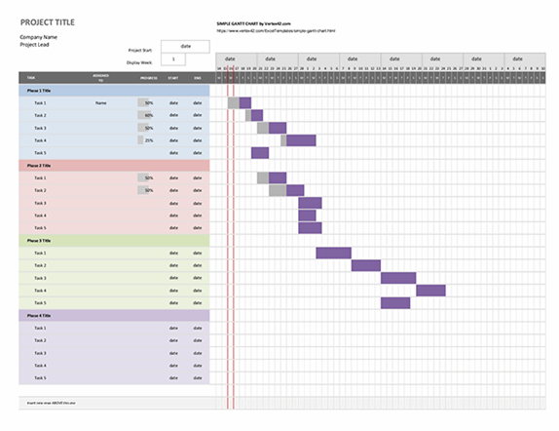

## SCRUM Methodology (optional)

Sprints

## Project Management Tools

### GitHub Project

Description

Include screen shots

How it worked in practice

### GitHub

Description

How it is used

How it worked in practice

# Reflection

## Your views on the project

Describe how you feel the project went from your perspective.

## How could the project be developed further?

## Assessment of your learning.

Critically assess your learning. List what skills and competencies you have learned developed in this Continuous Assessment.

List which part of the project would need further development and itemize where you feel you have not satisfactorily completed the continuous assessment.

## Completing a large software development project

Describe what you have learnt from the project, from the point of view of completing a large software development project.

## Technical skills

Describe what you have learnt from the project, from a technical skills viewpoint.

## Further competencies and skills

Describe any extra competencies and skills that would help you with your development in the workplace.

# References

Add a list of references that you used to complete the project.

The Department of Technology and Psychology in IADT uses APA 7th referencing style.

Use alphabetical order for your references.

This site gives details about how to cite websites using APA:

https://www.wikihow.com/Cite-a-Website-in-APA

The following is a useful site for creating citations for APA for websites.

<http://www.citationmachine.net/apa/cite-a-website>

You can also use the Referencing tab within Microsoft Word to enter reference information manually. Word then creates an APA style reference.